**Student Schedule UML Diagram**

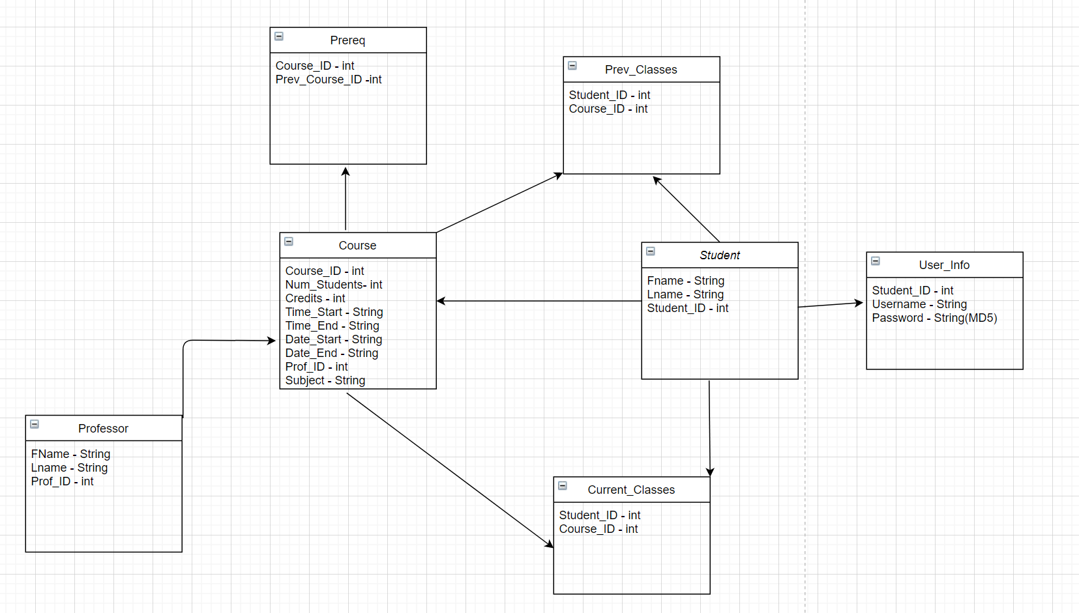

**User_Info:**

* Student_ID || Primary Key -Stores the students unique ID Number
* Username || Stores the student’s login Username
* Password || Stores the student’s login Password, encrypted in MD5

**Student:**

* Fname || Stores student’s first name
* Lname || Stores student’s last name
* Student_ID || Primary Key -Stores the students unique ID Number

**Professor:**

* Fname || Stores professor’s first name
* Lname || Stores professor’s last name
* Prof_ID || Primary Key - Stores the professors unique ID Number.

**Course:**

* Course_ID || Primary Key - Stores the courses unique ID Number.
* Num_Students || Current number of students in course
* Credits || Stores the numbers of credits the course awards.
* Time Start || Stores the start time in Hour: Min format
* Time End || Stores the end time in Hour: Min format
* Date_Start || Stores the date that the course starts.
* Date_End || Stores the date the course ends.
* Prof_ID || Stores the professor currently teaching the course.

**Current_Classes:**

* Student_ID || Foreign Key Stores the students unique ID Number
* Course_ID || Foreign Key Stores students’ course in schedule

**Prev_Classes:**

* Student_ID || Foreign Key Stores the students unique ID Number
* Course_ID || Foreign Key Stores students’ previous courses

**Prereq:**

* Course_ID || Foreign Key Stores the Course_ID
* Prev_Course_ID || Foreign Key Stores the prerequisite class required for that course